*This is for those who want to be apart of the Not Alone journey*.

**Not Alone**

My Story with Quinn Van Bergen

By Jacqueline Monetta

I have put off writing this for quite some time now, two years, and seven months to be exact. And yet, I sit down tonight with a blank screen in front of me and a million of thoughts, but no words. It’s funny how your mind can race in all directions, but when you have to write or talk, you have nothing to say. This is for all the teens that have so much to say with no voice.

I am who I am today because of a girl name Quinn. Quinn could make me laugh to a point where my stomach would ache and usually in the most inappropriate places, at the most inappropriate times. In fact, sometimes I would have to tell myself, “Do not look at her,” because I knew if I did I would burst out laughing in the middle of church or class. She was “basic” in the way she loved pumpkin spice lattes and UGGs but unique in the sense that people were just drawn to her and wanted to be her friend. The best days with Quinn weren’t the days of big events, but rather the days we spent watching a movie together on a Friday night, having a lunch date at school, attempting to make a Coke bottle explode with Mentos, spending several hours playing the piano, and telling countless stories. She helped me enjoy small moments no one pays attention to and helped me realize to not take life so seriously because no matter what we did, she was always smiling. She became the sister I never had. She was immensely loved by her supportive family and cherished by her friends.

But that day she didn’t see it. She didn’t know how much everyone loved her. She didn’t feel like she could talk to me, to our friends, or to her family. She didn’t know I would do anything for her to take back her decision. Because on that day, October 27, 2011, Quinn took her life leaving me with questions I thought I never would have answers to.

**October 27, 2011:** On Thursday morning, I answered my phone effortlessly not knowing it would change my life. When I registered the words I was hearing, my legs gave out and I fell to the floor. My face lost all emotion and I couldn’t speak. I felt it couldn’t be true. But the fact of the matter was that she was gone, gone forever.

As I ran into my parents room the reality of what I just heard hit me and I started uncontrollably sobbing. I told my parents as best as I could and they got up and just hugged me and started to cry too. How could this happen? How could my best friend kill herself? Was she really that tired of living? Why couldn’t I, her best friend, help her? What could I have done?

The next few days were in a blur. Memorials, prayer services, and ceremonies filled the next few days. I couldn’t grasp the fact that I wouldn’t see Quinn the next day. I kept wishing that she could be there to comfort me because she always knew how to make me smile. I kept thinking back on the past week looking to see if I was missing something. I remember sitting with her on Wednesday at lunch and her acting a little different. After school we sat at our daily bench and soon said bye to each other. “Bye Qui, see you tomorrow,” I said. “Bye Jax, see you tomorrow,” she said. More than ever do I wish that was true.

The next few months I felt drained and helpless. I cried myself to sleep most nights and started to close up my emotions. I didn’t know how to express myself anymore and I just wanted to pretend it didn’t happen.

**Journal Entry: November 27, 2011**

I miss you so much. I miss everything about you. I wish that was enough to bring you back, but it’s not. Everyday I experience something that I need to talk to you about. Sometimes, I’m so angry with you, other times I am so sad you aren’t here. How am I supposed to move on? How could you do this to me, your family, and your friends? I don’t know how to feel anymore. I don’t know what to do anymore. All I know is that I miss you. I don’t want to forget you. I don’t want to forget all the memories we’ve shared, your voice, our inside jokes, your smile. I just wish I could’ve said goodbye. I don’t know what I would say or if I would say anything at all. I wish I could hug you and tell you that everything will be ok. All I know is that I miss you and love you.

xoxo

Jacqueline

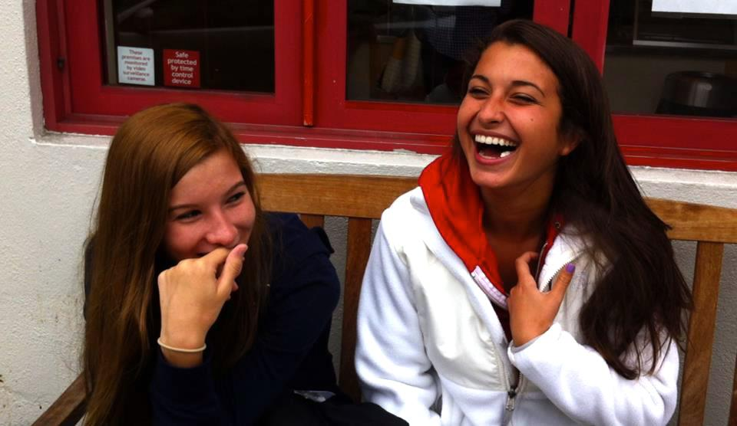

Over the next six months, I counted at least five other teen suicides around the Bay Area. I couldn’t understand why this was happening or why students thought this was an option. I needed answers.  I needed to know how I could help. I needed to know why.

As I looked on the Internet, I found pages and pages of different films on teen suicide, all by adults, none from a teen perspective. I realized if I couldn’t relate to any of these videos, how could a teen in need relate? I began by meeting with organizations, experts, professors, teachers, psychiatrists, and parents to learn more about depression and suicide. NAMOI, Edgewood, Marin Family Service Agency, San Francisco Suicide Prevention, and Grace Magill Project. I took seminars that taught me how to help someone who is suicidal. I became so engulfed in the topics it practically became what I knew best. But, I still didn’t know why. I knew all the facts are about depression and suicide. But I couldn’t feel it. I needed to hear from someone who’d been there.

Talking with students who have thought about suicide, I learned what depression really is. I meet Quinn again and again with each of peers. But through their stories, I have healed as I now have a bigger understanding of what my peers have gone through.

Each teen I interviewed has a very vivid definition of depression that was unique to the experience they endured whether it was abuse, a traumatic event or sometimes just the pressure of school. Regardless of their reasons, they all shared the same pain. They were immensely different in regards to their interests, family background, and really just who they are: an artist, a model, an athlete, a boy scout, a musician, someone with anxiety, someone who suffered from anorexia, a drug user. However, no matter how different they are, they all said the same thing. They felt alone with no one to talk to.

Not Alone will show the realness of teen depression in our society. I want to encourage students to reach out and know that they are **not alone.** Lastly, it is my wish to bring together those who feel isolated, open up the eyes of those who are unaware of the severity, and give a sense of hope for those who feel discouraged

Through my own experience and the stories of teens, don’t wait. Don’t wait to see if your friend’s mood will change in the next month. Don’t wait to talk to a friend. What’s the worst thing that could happen with just a simple question, how are you today? Tell your friends you care about them and just listen. Know that your friends are there for you to reach out. We have the power to help each other more than any expert or professional can. We are the front line and we need to act now. I wish I had.